Ocean Experiments
4th Grade

Activity Helpers to Do:
- During the presentation, set up the 3 stations as noted below and review the activity and goal.
- Rotate stations every 7-10 minutes allowing for student hands-on experience.

Station #1 – Salinity/Buoyancy: How the ocean’s salinity affects an object's ability to float.

Station Set Up
50 ml graduated cylinders with stands – 2 per student (AE lead: science closet)
Pony beads - about 10-12 per student
Chopstick stick for stirring – 1 per student
1/8 teaspoon measure 3-4 for the table
Salt in a container (AE lead: up to 1 teaspoon per student)
*Strainer for draining water/capturing beads at the class sink
*Plastic water pitcher filled with warm tap water (use at the table to fill the measuring cups)
*Measuring cups with spouts – 2-3 for the table for students to pour water into the cylinders
*Plastic tablecloth / Few Classroom Paper towels

Experiment: Slowly add salt to get the beads to first suspend in the water and then secondly to float on the top.
- Explain to the students that the more salt there is in water the denser it is.
- ASK: “Do you think the density of seawater affects an object’s ability to float (buoyancy)?” SAY: “Let’s do an experiment and see how little salt is needed to get these beads to first suspend in the water and then secondly to float on the top. Listen carefully because in science we want to BE PRECISE.”
- Students:
  - Add water to the 50ml line of both test tubes.
  - Drop 5-6 pony beads into each cylinder and gently prod them until they settle on the bottom. Remove any beds that won’t sink and drop in again or set aside.
  - Add ONLY a flat 1/8 teaspoon of salt to ONE of the test tubes.
  - Stir about 20-30 times.
  - ASK: anyone get them to suspend/stop partway? Are the beads on the bottom/top?
  - Add another flat 1/8 teaspoon, stir 20-30 times and see what the effect is.
  - If not on top, repeat one last time with an 1/8 tsp as that should be sufficient.
- ASK: What does this show us? *It is easier to float in saltier water. The salt water has to be denser then the object for the object to float.
- If time allows, students can repeat the experiment in the other cylinder or just use the cylinder to compare freshwater to salt water results.
- When finished, students empty test tubes through the strainer at the sink (another station needs the sink too).
Station 2 - Salinity: How salt content affects the weight of seawater.

Set Up Station for Teams of 2-3 students
Two clear plastic cups – per team
One tablespoon – per team
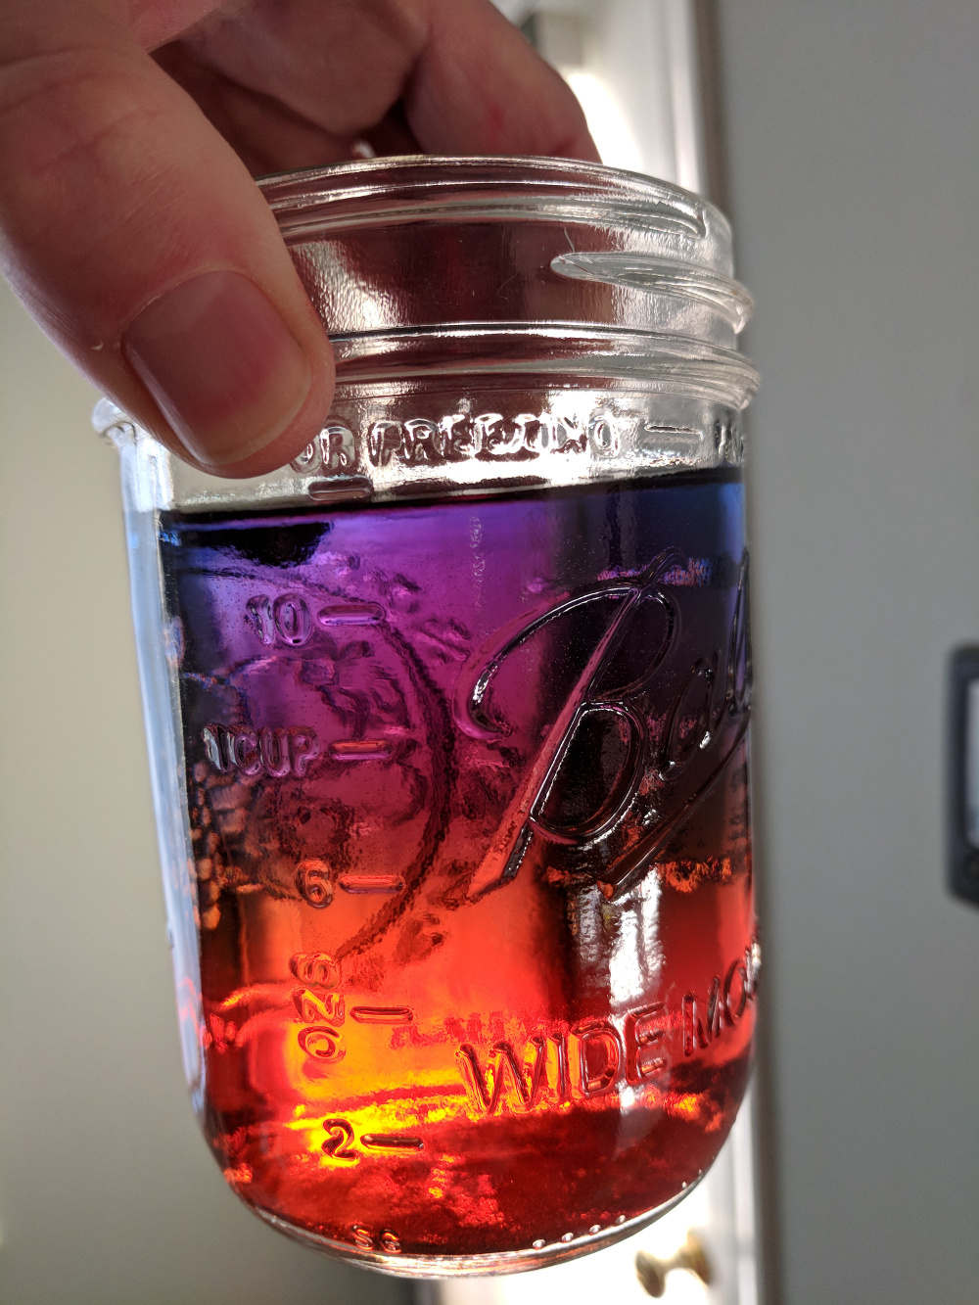
SHAKE the Container of colored salty “ocean water”
Container of colored “freshwater”
Plastic tablecloth / Few classroom paper towels
Laminated activity “how to” visual for guiding the students

Experiment:
- Using the visual, SAY:
  - The more salt there is in water, the heavier the water is.
  - For the activity, if you are slow and careful, you can layer fresh water on top of salty water.
  - Salt has been added to one water to represent salty ocean water.
  - The other colored water represents fresh/non-salty water.
  - SAY: “Let’s listen carefully because in science we want to BE PRECISE. Let’s follow the steps along together.”

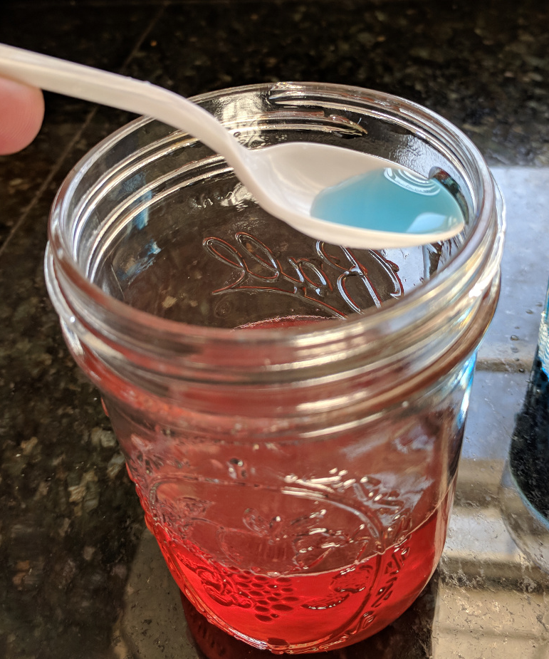
- Using the visual, review ALL activity steps BEFORE they pour the water as students can get eager and jump ahead. Recommend using an instructor set of cups and a spoon to demonstrate SLOW pouring over the spoon or use one of the team’s set. STEPS:
  - Students fill to the marked lines, one cup with the salty water and one cup with fresh water.
  - One student holds the spoon against the inside of the SALTY cup. (See Photo)
  - One student VERY slowly dribbles the fresh water onto the spoon.
  - If the water is added too fast, the layers will mix and the experiment will fail.

- Explain to the students that the more salt there is in the water the denser/heavier it is. Heavier water sinks to lower levels. Freshwater is less dense and settles on top of denser water.

- When finished, students can empty cups at the sink (another station needs the sink too).
Note: Please save any unused colored water for future classes. Please rinse and dry items and place all supplies back in the appropriate bag/box, collect the presentation, activity and log in instructions and return the supplies to the teacher workroom. Thank you!

Station 3 Part 1 - Pressure
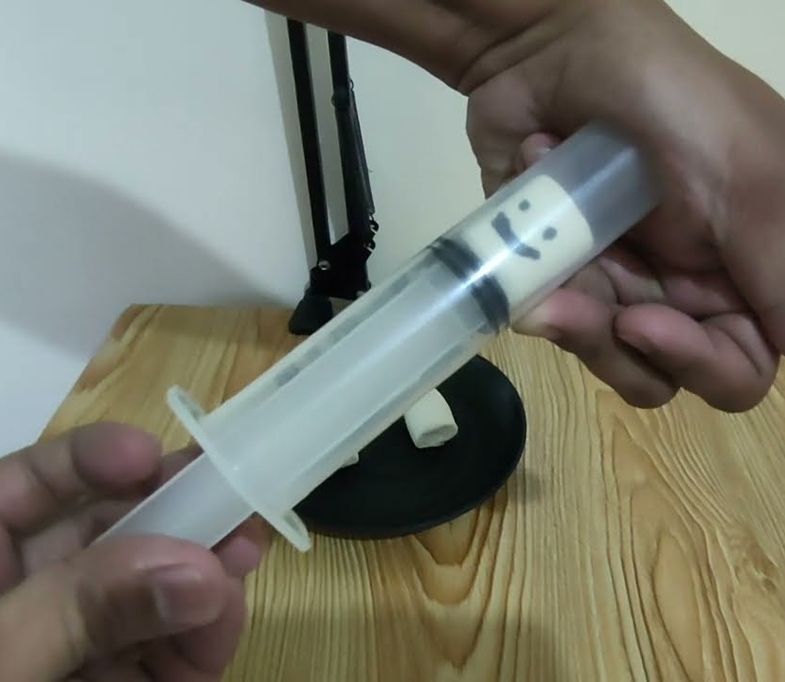
Materials Per Student
Syringe
ONE Marshmallow
Thin Marker from classroom

Experiment:
ASK the students: “have you ever been diving in a pool or flown in an airplane? What happens to your ears?” They are affected by the changing pressure levels. SAY: “Let’s experiment with increasing and decreasing pressure environments. Let’s listen carefully because in science we want to BE PRECISE. Let’s follow the steps along together.”

Steps:
- Each student gets ONE marshmallow.
- Ask them to draw a face on the marshmallow.
- Give the syringe, tell them NO squishing or the syringes won’t work for next group.
- SAY: to demonstrate a LOW-pressure environment:
  - put the marshmallow into the syringe.
  - push the plunger until it’s SLIGHTY touching the marshmallow (NO squishing).
  - put your finger over the tip.
  - while looking at the marshmallow face, slowly pull the plunger out as far as it can go and watch the marshmallow (it will swell).
- SAY: to demonstrate a HIGH-pressure environment:
  - remove the plunger from the syringe.
  - leave the marshmallow inside.
  - cover the tip of the syringe and replace the plunger.
  - look at the marshmallow face.
  - without letting any air escape from the tip, press hard and watch the marshmallow (it shrinks).

Discussion points:
- What happened to the marshmallow under high-pressure? It shrinks.

- What do you think would happen to your body if you tried to dive to the Mariana Trench where there is extreme high-pressure? Your lungs would collapse/implode.

- What would happen to your body in an extreme low-pressure environment? At low pressure, gases escape from liquids much more easily. If you were in an extreme low-pressure environment, your body would start to boil. Fortunately, it’s not likely you’ll be visiting these environments, but the science is fun!

Station #3 Part 2 – Starfish

Materials
Starfish

TALKING POINTS:

ASK: Has anyone seen a starfish before?

Some interesting facts about starfish:

Despite their name, starfish are not actually fish. Since they don’t have a backbone, they belong to a group of species called invertebrates, which also includes urchins and sponges.
There are around 1,600 different species of starfish living in the world’s oceans, where they occupy every type of habitat including tidal pools, rocky shores, sea grass, kelp beds and coral reefs.
Most starfish sport spiny skin and five arms surrounding a central disk-shape body – although some can grow as many as 50 arms.
Starfish can regenerate/regrow their own arms. Arms can take months, even years to fully regenerate, so it has to be a pretty serious situation to lose one.
They also have eyespots on the tips of the arms, which allow the starfish to sense light and dark, and help it find food.
Their arms are covered with pincer-like organs and suckers that allow the animal to slowly creep along the ocean floor.
They have a surprisingly unusual anatomy, with no brain or blood, and they have a stomach that can digest food outside their body.

