Solar System Activities
4th Grade

Activity Helper Tasks:
- During the presentation, set up as noted below.
- Review the activities to understand the goal and prompt student thinking and learning.
- There are two scale modeling activities. The first in teams of 2; the second as a class.

Activity One: Play-Doh Planets
Supplies for teams of two:
- Two cans of Play-Doh *students do NOT keep planet models
- One plastic knife
- One laminated planet mat
- One laminated Play-Doh Planets instruction sheet

Lesson
- Students follow the Play-Doh Planets instruction sheet to make planets to scale.
- Students will find it easiest to divide the Play-Doh into 8 equal sized pieces by rolling it into a hot dog shape and then cutting it in half and then each half again until they have 8 pieces.
- As they separate the pieces to form a specific planet, they should place them on the appropriate planet on the planet map.
- When complete, students can visualize the size differences and will discover that more than 96 percent of the combined volume of the planets comes from two gas giants: Jupiter and Saturn (60% Jupiter and 36% Saturn).
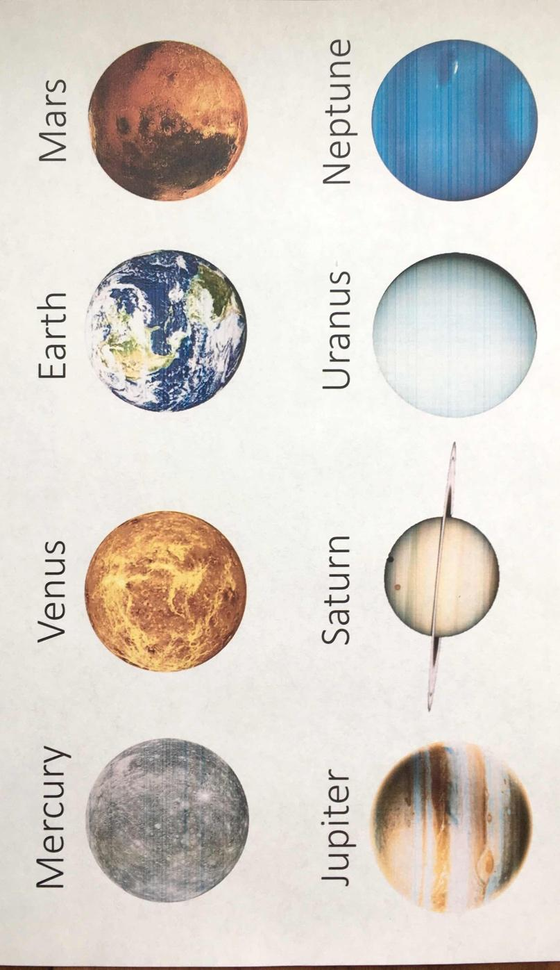

Activity Two: Toilet Paper Solar System
Supplies for one class group:
- One roll of 100 sheets of toilet paper
- Laminated planet/Sun cards
- One team’s set of Play-Doh planet models

Lesson
As a leader-led activity, the class will build one large scale model of the distances in the solar system using a roll of toilet paper and one set of the Play-Doh planet models. The activity requires about 30-32 feet and can be conducted in the classroom or pod.

Select Students to:
- Place the Sun card at the starting location
- Unroll toilet paper
- Place a Play-Doh planet to mark a planet’s distance/location on the toilet paper
- Place the planet’s card beside the Play-Doh planet.
Note: the table number column reflects the number of toilet paper sheets needed to reach the planet FROM THE SUN, not from the previous planet.

Scale
Mercury is 35,983,610 miles away from the Sun.
The below chart uses the scale of 1 square of toilet paper equaling the distance of about 36 million miles.

Planet | Squares of Toilet Paper  FROM the SUN | Distance to the Sun  Approximate millions of miles
Mercury | 1.0 | About 36 MM
Venus | 1.9 | 67 MM
Earth | 2.6 | 93 MM
Mars | 3.9 | 142 MM
Jupiter | 13.4 | 484 MM
Saturn | 24.7 | 890 MM
Uranus | 49.6 | 1.8 BILLION Miles
Neptune | 77.8 | 2.8 BILLION Miles

Note: Please COLLECT Play-Doh and divide back evenly into cans so it can be re-used for future classes. Please place all supplies back in the appropriate bag/box together with the presentation document, activity and server login instructions, and return the session supplies to the teacher workroom. Thank you!

