GREAT ART MARCH SESSION

Some specific notes about Great Art’s March Session:
- March session is Raina Telgemeier.
- Students will learn about Raina Telgemeier and create their own comic inspired by Telgemeier’s comics, and desire to share her life experiences and feelings. Raina Telgemeier is a famous American cartoonist. She is the writer and illustrator of popular graphic novels, such as Smile and Sisters.
- Art project: create your own comic strip using markers/colored pencils and various face (eyes, nose, mouth) stickers.
All grades will use the same project materials, except K-2 will have some pre-drawn comic strip panels.

PLEASE NOTE — it is better to keep the presentation short and allow for more time to work on the art project. Aim for about a 10-15 minute presentation/discussion. Feel free to cut and shorten where needed, focusing on the 3 BIG IDEAS.
The PowerPoint presentation covers a lot of material and there is room for class discussion. Specifically, for younger students (grades K-2), keep your audience in mind and skip over information as needed. Focus on the 3 big ideas. Remember to be mindful of the time and allow plenty of time to work on the art project.

General Information:
- You can preview the Hunter presentation, activity, and our FAQ section on the Great Art PTBoard page (click Great Art).
- Review the presenter notes in the PowerPoint.
- Paper copies of the presentation with the speaker notes, and the activity instructions are provided in the binder on the Great Art carts.
- The presenter picks up the activity materials located in the teacher workroom.
  - As you enter the K-3 hallway, turn left towards the playground doors, immediately on the right is the workroom. Supplies are located on the Great Art carts on the left side of the teacher workroom. There is one cart for grades K-2, and one cart for grades 3-6.
- The teacher will bring up the presentation using a school laptop.
- Please plan to arrive 15 minutes early to set up.
- Please return all materials promptly.
- Have fun!

We appreciate your help returning all art materials to the carts. Please let us know (svesptagreatart@gmail.com) if anything needs to be restocked or is missing.

Thanks again for volunteering and making Great Art a success!

TEACHER INSTRUCTION - BACKUP INFORMATION
Set Computer Display Mode to “Duplicate” for Presentations with Videos
- Right click on the desktop and select display settings.
- Scroll to multiple displays and select duplicate.
Instructions for Logging in and Accessing Volunteer Materials
- Borrow a student laptop (Recommendation: choose first student laptop on roster.)

- Login with the Sunrise Valley visitor profile:
  - u: 3325visitor
  - p: Solarflare1
- Click on folder on bottom taskbar (File Explorer).
- Open SubVolunteers Server (in Network Locations).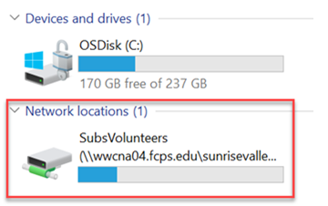
- Select either Amazing Earth or Great Art.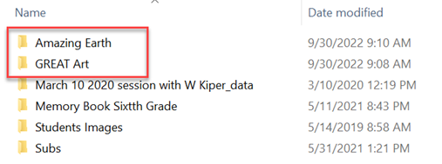
- Materials will be organized by grade level and by month. Current month will be starred and at the top of the list. (Tip: look for the most recently modified items within folders.)

